**Agile Development Management Tool Usage Survey**

How old are you? 您的年龄是？ [单选题]

|  |  |  |
| --- | --- | --- |
| 选项 | 小计 | 比例 |
| Age younger than 18 | 2 | 0.77% |
| 18 ＜ Age ≤ 26 | 64 | 24.52% |
| 26 ＜ Age ≤ 36 | 163 | 62.45% |
| 36 ＜ Age ≤ 46 | 28 | 10.73% |
| Age older than 46 | 4 | 1.53% |
| 本题有效填写人次 | 261 |  |

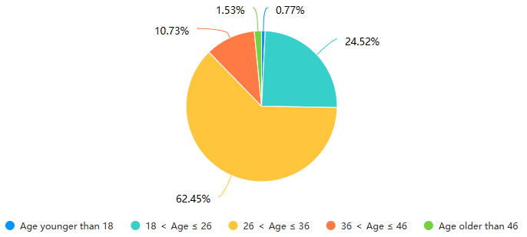

What is your gender? 您的性别是？ [单选题]

|  |  |  |
| --- | --- | --- |
| 选项 | 小计 | 比例 |
| Male | 182 | 69.73% |
| Female | 74 | 28.35% |
| Other | 2 | 0.77% |
| Not convenient to disclose | 3 | 1.15% |
| 本题有效填写人次 | 261 |  |

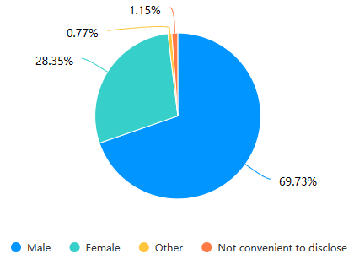

How many years of development experience? 您从事开发相关经验有几年？ [填空题]

填空题数据请通过下载详细数据获取

Which development role best describes you? [Select all that apply] 哪个开发角色最能描述您？[选择所有符合条件的] [多选题]

|  |  |  |
| --- | --- | --- |
| 选项 | 小计 | 比例 |
| Developer/Programmer 开发人员/程序员 | 127 | 48.66% |
| Project Manager 项目管理者 | 93 | 35.63% |
| Scrum Master 敏捷管理者 | 29 | 11.11% |
| Product Owner 项目拥有者 | 18 | 6.9% |
| Quality Assurance/Testing 质量保证/测试人员 | 48 | 18.39% |
| Other (Please specify) | 2 | 0.77% |
| 本题有效填写人次 | 261 |  |

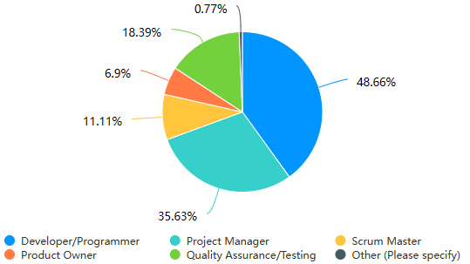

Rate your familiarity of agile development methodologies?评价您对敏捷开发方法的熟悉程度吗？ [单选题]

|  |  |  |
| --- | --- | --- |
| 选项 | 小计 | 比例 |
| Very familiar 非常熟悉 | 64 | 24.52% |
| Moderately familiar 比较熟悉 | 146 | 55.94% |
| A little familiar 有点熟悉 | 38 | 14.56% |
| Not familiar at all 不熟悉 | 13 | 4.98% |
| 本题有效填写人次 | 261 |  |

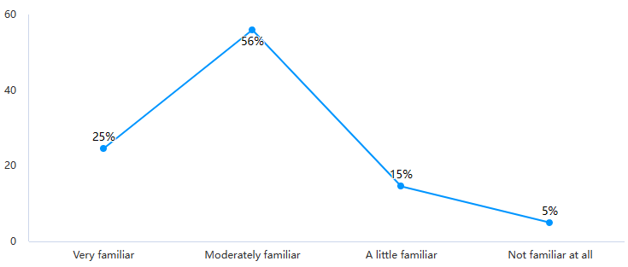

Have you worked on, or managed projects adopted agile development methodologies?您是否参与或管理过采用过敏捷开发方法的项目？ [单选题]

|  |  |  |
| --- | --- | --- |
| 选项 | 小计 | 比例 |
| Yes | 152 | 58.24% |
| No | 109 | 41.76% |
| 本题有效填写人次 | 261 |  |

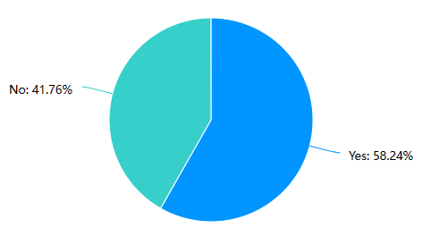

Have you tried any of these agile development tools? [Select all that apply]您尝试过这些敏捷开发工具吗？ [选择所有符合条件的] [多选题]

|  |  |  |
| --- | --- | --- |
| 选项 | 小计 | 比例 |
| Trello (trello.com) | 67 | 44.08% |
| ClipUp (clickup.com) | 62 | 40.79% |
| Wrike (wrike.com) | 62 | 40.79% |
| Jira in Atlassian (atlassian.com) | 64 | 42.11% |
| Monday.COM (monday.com) | 40 | 26.32% |
| Taiga (taiga.io) | 25 | 16.45% |
| Other (Please describe) | 1 | 0.66% |
| 本题有效填写人次 | 152 |  |

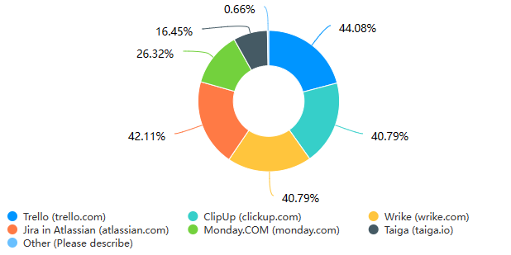

Do you use agile development technologies in your projects often?您在项目中使用敏捷开发技术的频率是？ [单选题]

|  |  |  |
| --- | --- | --- |
| 选项 | 小计 | 比例 |
| Daily 每天 | 29 | 19.08% |
| Multiple times a week 一周多次 | 89 | 58.55% |
| Weekly 每周 | 27 | 17.76% |
| Occasionally 偶尔 | 5 | 3.29% |
| Rarely 很少 | 2 | 1.32% |
| 本题有效填写人次 | 152 |  |

Please rate the following statements based on your experiences and perceptions of agile development tool usage.请根据您对敏捷开发工具使用的经验和看法对以下陈述进行评分。 [矩阵单选题]

|  |  |  |  |  |  |
| --- | --- | --- | --- | --- | --- |
| 题目\选项 | Strongly Disagree 非常不认同 | Disagree 不认同 | Neither Disagree nor Agree 中立 | Agree 同意 | Strongly Agree 非常同意 |
| Agile development tools complement project management well. 敏捷开发工具很好地辅助了项目管理。 | 2(1.32%) | 3(1.97%) | 15(9.87%) | 92(60.53%) | 40(26.32%) |
| Agile development tools improve team communication. 敏捷开发工具改善了团队沟通。 | 4(2.63%) | 5(3.29%) | 23(15.13%) | 67(44.08%) | 53(34.87%) |
| Agile development tools streamline project management. 敏捷开发工具简化了项目的管理。 | 2(1.32%) | 1(0.66%) | 30(19.74%) | 68(44.74%) | 51(33.55%) |
| Agile development tools provide project data and performance evaluation insights. 敏捷开发工具能提供项目数据和性能评估的见解。 | 2(1.32%) | 4(2.63%) | 22(14.47%) | 82(53.95%) | 42(27.63%) |
| Agile tools handle shifting requirements and iterations well. 敏捷工具可以很好地处理不断变化的需求和迭代。 | 3(1.97%) | 4(2.63%) | 33(21.71%) | 77(50.66%) | 35(23.03%) |
| Agile development tools include an easy-to-use UI. 敏捷开发工具的UI易于使用。 | 3(1.97%) | 9(5.92%) | 33(21.71%) | 73(48.03%) | 34(22.37%) |
| Agile development tools provide excellent support and documentation. 敏捷开发工具提供出色的支持和文档。 | 2(1.32%) | 4(2.63%) | 30(19.74%) | 66(43.42%) | 50(32.89%) |
| Agile development tools integrate well with other software development tools/systems. 敏捷开发工具可以与其他软件开发工具/系统很好地集成。 | 3(1.97%) | 4(2.63%) | 30(19.74%) | 68(44.74%) | 47(30.92%) |
| Agile development tools effectively address project security and data privacy. 敏捷开发工具有效解决项目安全和数据隐私问题。 | 4(2.63%) | 8(5.26%) | 39(25.66%) | 66(43.42%) | 35(23.03%) |
| I like our agile development tools. 我喜欢使用敏捷开发工具。 | 2(1.32%) | 4(2.63%) | 21(13.82%) | 75(49.34%) | 50(32.89%) |

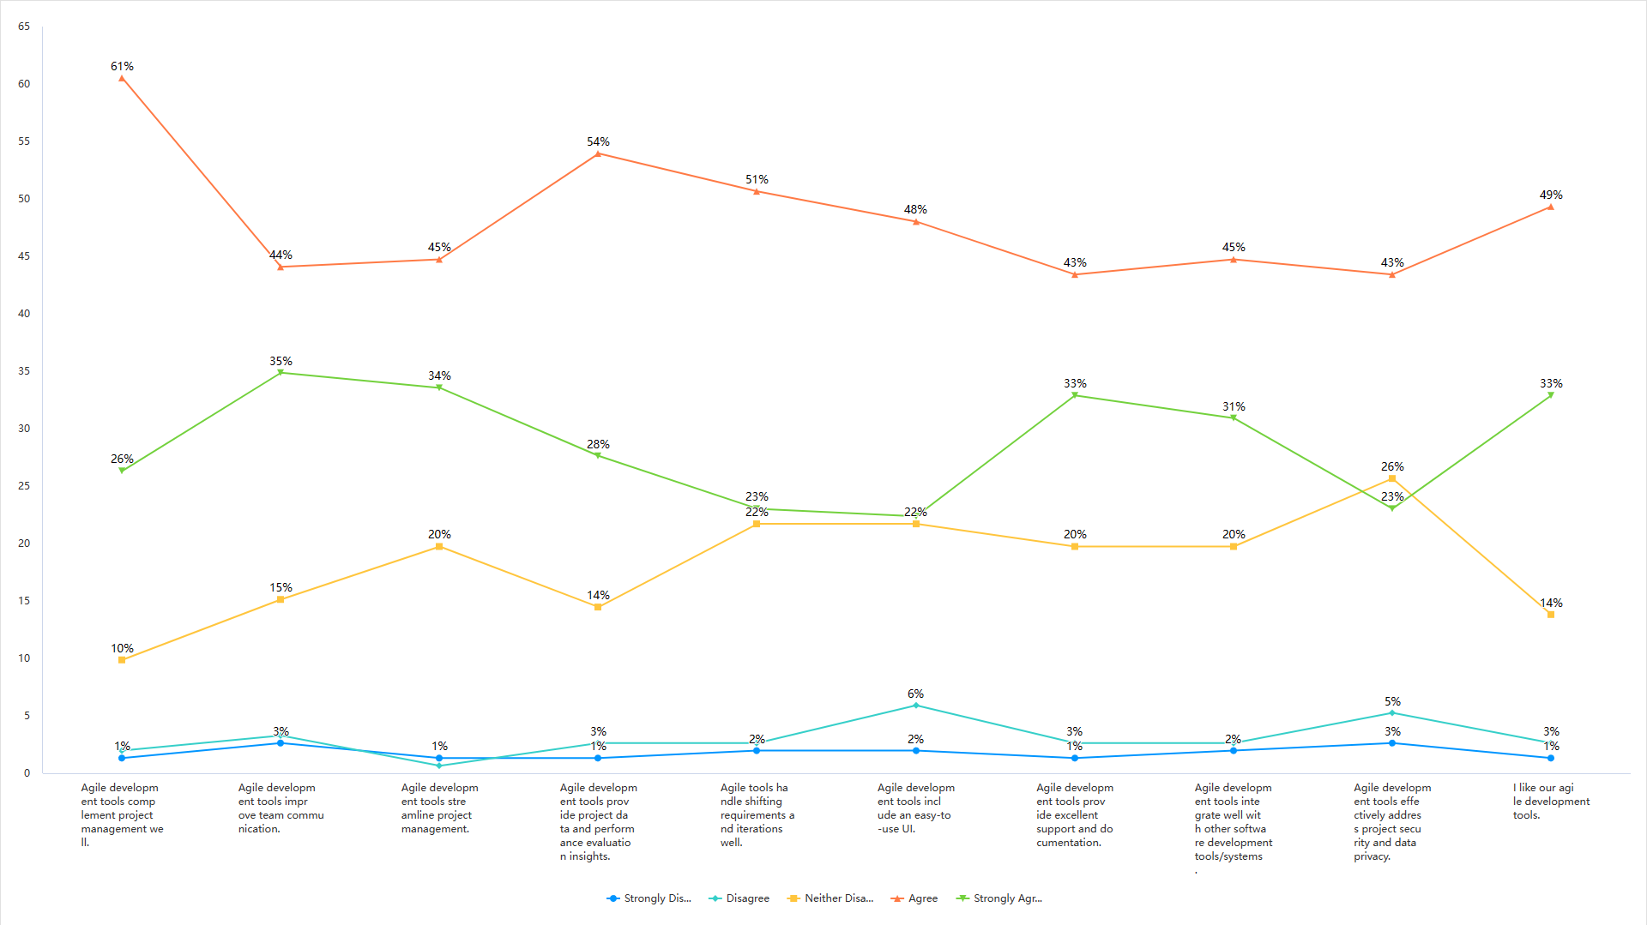

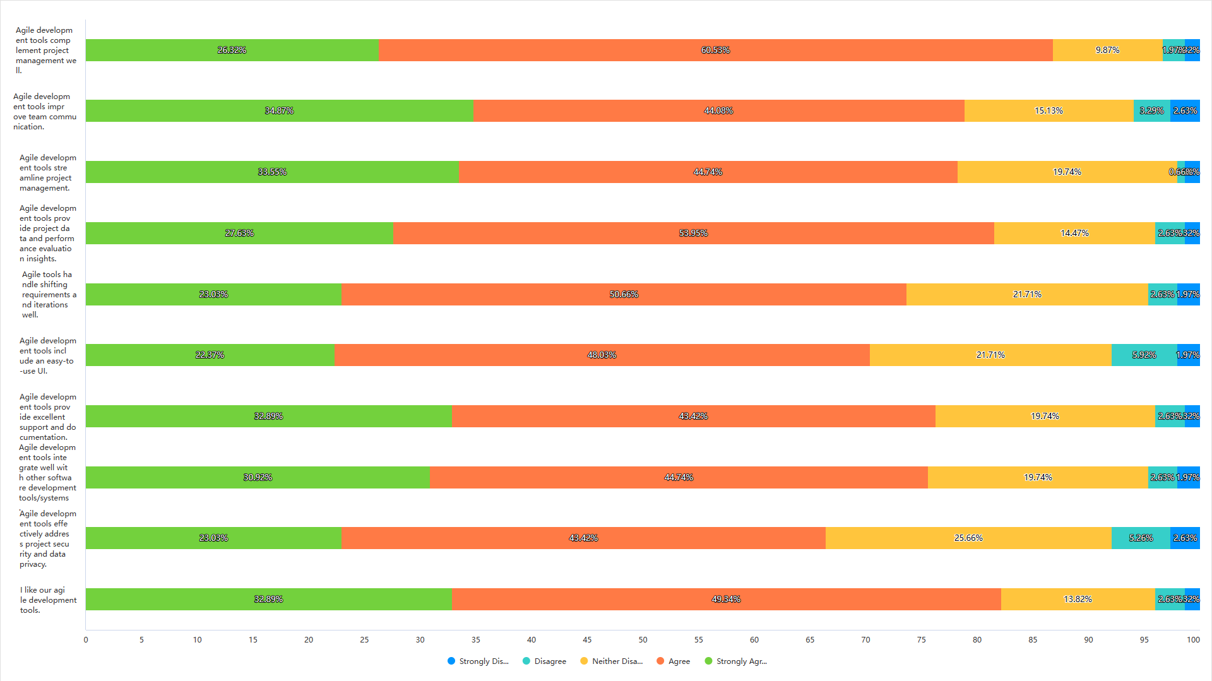

How do agile development tools aid you?敏捷开发工具如何帮助（辅助）您？ [矩阵单选题]

|  |  |  |  |  |  |
| --- | --- | --- | --- | --- | --- |
| 题目\选项 | Strongly Disagree 非常不认同 | Disagree 不认同 | Neither Disagree nor Agree 中立 | Agree 同意 | Strongly Agree 非常同意 |
| Better collaboration and communication. 更好的协作和沟通。 | 5(3.29%) | 6(3.95%) | 9(5.92%) | 78(51.32%) | 54(35.53%) |
| Project visibility and tracking. 项目可见性和跟踪。 | 4(2.63%) | 3(1.97%) | 27(17.76%) | 67(44.08%) | 51(33.55%) |
| Productivity and efficiency. 生产力和效率。 | 4(2.63%) | 1(0.66%) | 22(14.47%) | 65(42.76%) | 60(39.47%) |
| Backlog and user story management. 待办事项和用户故事管理。 | 3(1.97%) | 5(3.29%) | 18(11.84%) | 77(50.66%) | 49(32.24%) |
| Streamlined release management. 简化的发布管理。 | 3(1.97%) | 4(2.63%) | 16(10.53%) | 68(44.74%) | 61(40.13%) |

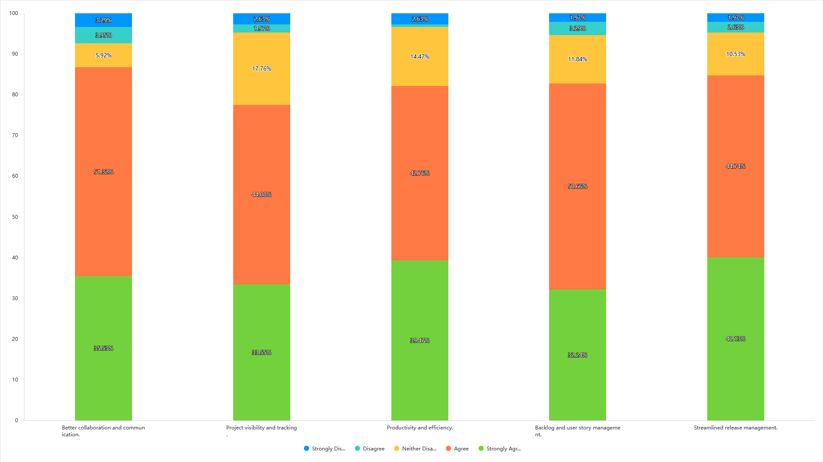

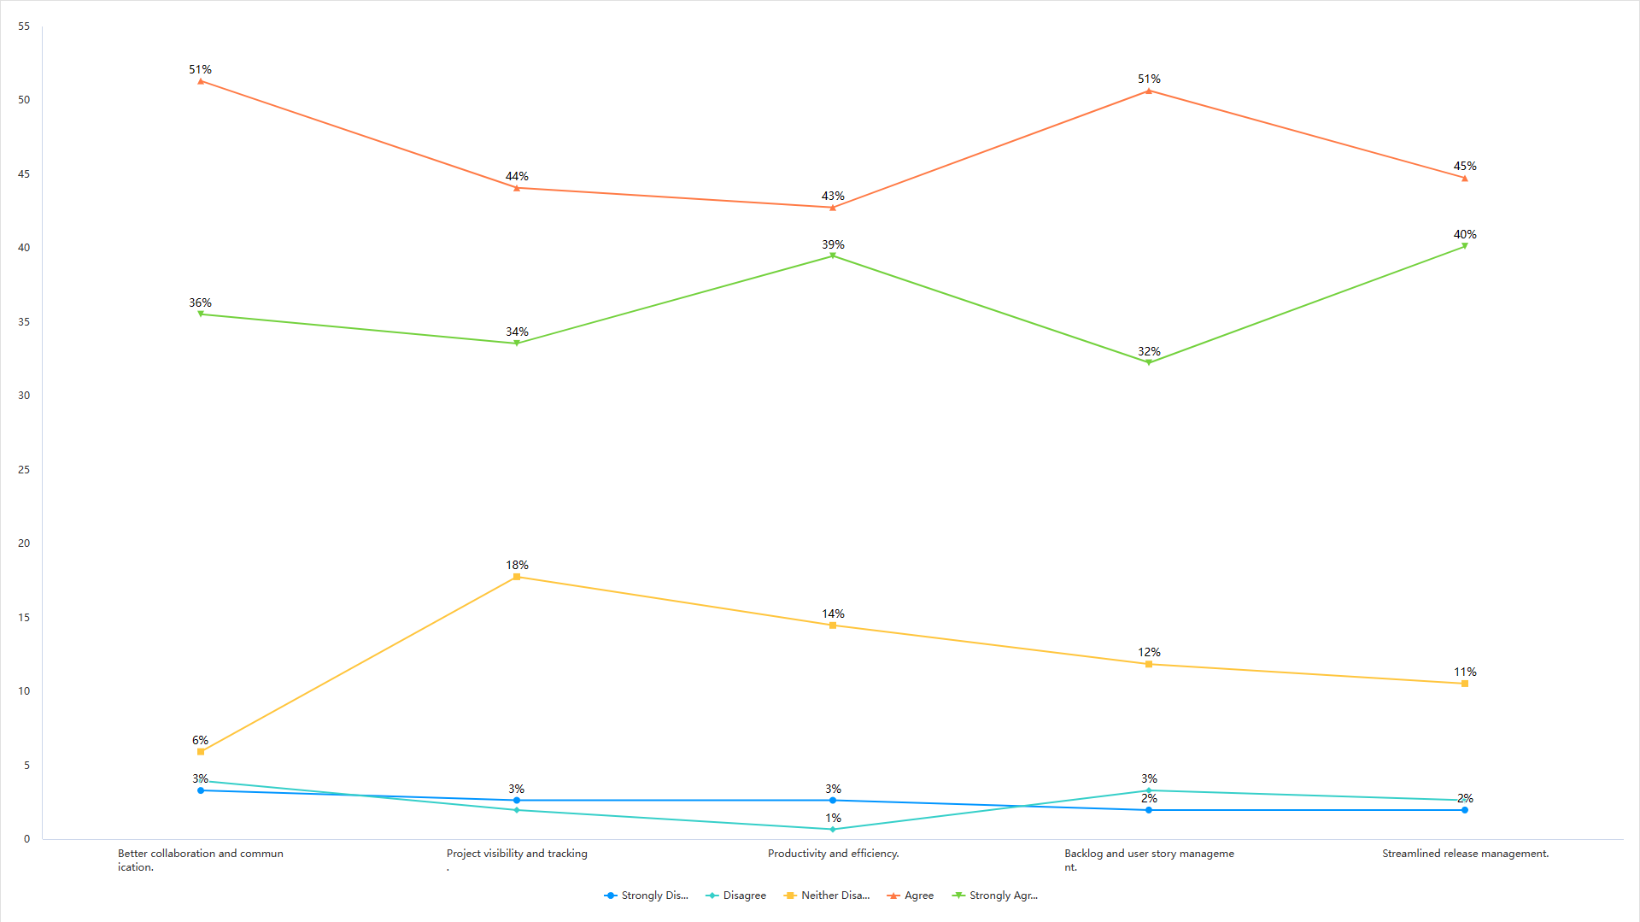

What problems do you encounter with agile development tools? Or think there is something that could be improved?您在使用敏捷开发工具时遇到了哪些问题？ 或者认为有什么可以改进的地方？ [填空题]

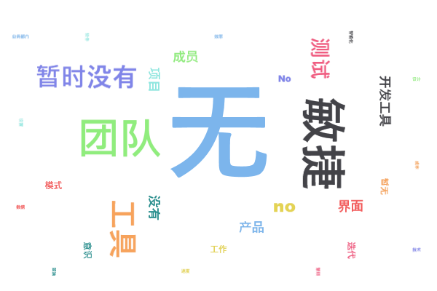

If you are interested in participating in the interview on the improvement of agile development management tools, please leave your email. Thank you very much for your support!如果您有兴趣参与敏捷开发管理工具改进的访谈（有更多对工具使用的吐槽），请留下您的电子邮件。 非常感谢您的支持！ [填空题]

填空题数据请通过下载详细数据获取